**Brooklyn torah gazette**

**For parshas ki sisa 5783**

Volume 7, Issue 26 (Whole Number 333) 18 Adar 5783/ March 11, 2023

**Printed L’illuy nishmas Nechama bas R’ Noach, a”h**

For a free subscription, please forward your request to [***keren18@juno.com***](mailto:keren18@juno.com)

**How to Succeed**

**with Shidduchim:**

***Davening is Hishtadlus!***

**By Daniel Keren**

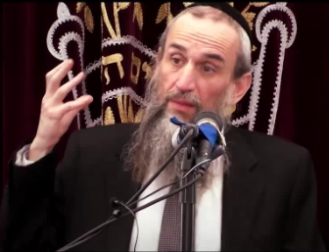

**Rabbi Zev Smith**

**Rabbi Zev Smith**, internationally renowned Maggid Shiur was one of the featured speakers at the recent President’s Day Hakhel Yarchei Kallah Event in Flatbush. He addressed the often-painful and complicated topic of “Shidduchim, Zivugim and Bashert: Essential Guidance and Guidelines.”)

Rabbi Smith began by declaring that a shidduch is undoubtedly one of the most important decisions one can ever make. What does the world “bashert” mean. It is a Yiddish word which means ‘pre-destined.” Bashert really means, Rabbi Smith emphasized “hashgacha pratis.”

A question one might ask is why should one push a particular shidduch if seeming obstacles pop up. We see, Rabbi Smith said, that when Eliezer the servant of Avrahom first proposed the shidduch (suggestion of marriage) between his master’s son Yitzchak and Rivka, both the girl’s father and brother initially declared – “this is from Hashem.”

**One Will Be Questioned in the Heavenly Court**

Chazal teach us that a person must do his or her hishtadlus (logical efforts) to achieve the goals of life, including pursuing shidduchim and getting married. When a person dies, he will be asked in the Bais Din shel Maila (the Heavenly Court,) if he was active in peruvu, procreation.

Rabbi Smith noted that not everybody who gets married is zoche (merits) to be blessed with children. Our Sages teach that the obligation to procreate refers to whether one was active in trying to help others find suitable shidduchim in order to get married and establish Jewish families.

A person with regards to shidduchim and other important aspects in life must have faith in bashert/hashgacha pratis and yet still focus on pursuing logical hishtadlus (i.e., by calling shadchanim/matchmakers or asking friends and neighbors for their suggestions.)

Perhaps the most important hishtadlus for one to carry out with regards to succeeding in the matter of shidduchim, according to Rabbi Smith is to actually daven (pray) to Hashem. We see that Eliezer, the loyal servant of Abraham davened to Hashem to help him find a proper shidduch for Yitzchak, his master’s son.

**The Achievement of Our Matriarch Leah**

We also see that our matriarch Leah was able to change her destiny [to marry Esav] by constantly davening to Hashem and to such an extent that her eyes became weak from her constant tears when praying to be allowed to marry a tzaddik (righteous man.) Davening, Rabbi Smith repeated is not just good idea, but it is the essential hishtadlus that one is obligated to carry out faithfully.

However, one should never ever daven to Hashem for a particular shidduch [i.e.; a certain man or a certain woman.) If it is bashert you will marry that person anyway. And if it is not bashert you should daven that the shidduch not even get to first base or if does begin, pray to Hashem that it end quickly.

The important aspect of hishtadlus is that it be done completely with honesty. What do you think will be accomplished if one utilizes deceit? Do you think that such a marriage will be smooth and both parties will be able to live happily ever after?

Rav Chatzkel Levenstein, 1885-1974 recalled that he would get up in the middle of a seuda (meal) before the fast of Yom Kippur if he thought he could just help to push a potential shidduch.

We all, Rabbi Smith emphasized, have an obligation to make shidduch suggestions. They will not occur on their own without our getting actively engaged in this important mitzvah for Klal Yisroel and our own obligation to help another Jew.

**Getting Lost in the Pursuit of**

**Foolish and Unimportant Side Issues**

Can a person actually miss his or her bashert? If a person is too picky, Rabbi Smith declared that yes one can lose his or her bashert. The crisis besetting our community today is that too many people, including the parents are lost in pursuing foolish inyonim (unimportant side issues.)

Rabbi Smith challenged the Hakhel audience by asking what is wrong with one marrying a girl or woman a few years older than him? One particular boy from Mesivta Torah Vodaath discovered after a few dates that the girl was a couple of years older than him. He confided to Rav Avrohom Pam, 1913-2001, that this knowledge of the girl’s age really bothered him. Rav Pam asked him, why let a couple of years get in the way of a sea of many happy years together? And because that boy had the good fortune of asking Daas Torah, he has now been married for many years with a beautiful family that now includes numerous grandchildren.

**One Should Never Pursue a Shidduch Out of Desperation**

If a person follows all the rules [of davening and hishtadlus] he will never lose out. One should not, Rabbi Smith said, pursue a shidduch because of external values (such as the wealth or prominence of the other person’s parents.) One should also not pursue a shidduch out of desperation if you find the boy or girl repulsive.

However, one should not quickly give up on a shidduch if you don’t perceive “fireworks,” if on the other hand the prospective mate is pleasant and otherwise good on paper with regards to other important aspects of a marriage.

Parents should let their child make their own decisions regarding a shidduch.

Rabbi Smith concluded his lecture by recalling something that Rav Moshe Feinstein, 1895-1986 said with regards to marriage. We must live with Emunah (faith in G-d) that when one gets married, one must understand that this spouse is our bashert and we must do everything to help make it work. Don’t allow yourself to think that you could have done better. People make things work if they understand that they are on the right track.

*Reprinted from March 9, 2023 edition of the Jewish Connection.*

**Rav Avigdor Miller**

**On Moshe’s Shidduch**

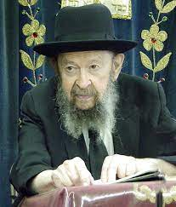

**QUESTION:** How is it that Moshe, the greatest man who ever lived, married a Midyanite woman, the daughter of Yisro?

**ANSWER:** You must understand, number one, a very great principle, that Hakodosh Boruch Hu is most interested in a person’s character. רחמנא לבא בעי – Hashem wants the heart.

And Yisro was a most remarkable man with a remarkable heart. He was a man who made a break with his past.  Yisro was a priest of idolatry and he was  enthusiastic about it too.  שפיטם עגלים לעבודה זרה – He used to fatten the calves for the idol. When he had a mitzvah of offering a calf, he refused to bring it right away; instead, he spent time fattening it so that it should be a mitzvah min hamuvchar.  He was an enthusiastic idolater.

And when this man finally discovered the truth he became an enemy of idolatry.  He became enthusiastic about fighting idolatry. And because of that, he was ostracized by his people.  He was in danger.  Nobody would even help him.  And the Medrash tells us that because of that his daughters had to go out and tend his sheep. And they were persecuted until Moshe came and he rescued the daughters from the persecutors. So, we see that Yisro was a man who was suffering for his principles.

Now when a man demonstrates greatness of soul, we don’t care what nation he’s from.  And therefore, Tziporah was certainly a fit wife for this great man, Moshe Rabbeinu. Because he too was able to ignore his environment.  He was born in a palace and he had all privileges and yet he forsook it to go out to help his downtrodden brothers.  And so, there’s no question that this was a perfect match and there’s nothing to criticize in the shidduch of Moshe Rabbeinu.

Now why did it turn out just like this? It could be hashgacha; Hashem wanted to teach this great lesson that the nations of the world can attain greatness if they’re willing to overstep the boundary between them and us.

And that’s what happened to great people in every generation. Rus became great because she forsook her nation and joined ours.  And if you look further, you find Shmaya v’Avtalyon, the great teachers of our people, also came from converts.  And you look further, you find even Rabbi Akiva is descended from converts.

Rabbi Akiva is the main teacher of our people in the period of the Tanaim, from the times of the Beis Hamikdosh until the milchemes Beitar; all that we have came through his mouth. And he was the son of converts.

You see Unkelus HaGer.  He made Targum Unkelus.  And his work is in the Chumash.  It’s even printed in the Chumash above Rashi Hakodosh.  Right next to the Torah itself.

And therefore, that’s a great principle that the doors are open for the chosen souls of the nations of the world.  And therefore, when you look at this inspiring story that Tzipora, a giyoress, was married to Moshe Rabbeinu, that’s a tremendous lesson for the world. The door to greatness is open for everyone.

*Reprinted from a recent email of Toras Avigdor. Adapted from Tape #449.*

**\*\*\*\*\*\*\*\*\*\*\*\*\*\*\*\*\*\*\*\*\*\*\*\*\*\*\*\*\*\*\*\*\*\*\*\*\*\*\*\*\*\*\*\*\*\*\*\*\*\*\*\*\*\*\*\*\*\*\*\*\*\*\*\*\*\***

*And you shall make a basin of copper... and they shall wash their hands and their feet (Ex 30:18, 21)*

Today, when prayer takes the place of the priests’ service in the Holy Temple, we wash our hands before praying. Yet unlike the priests of old, Maimonides concludes that also the face (in addition to the feet, if they warrant it) must be washed prior to praying. The hands and feet enable a person to act, but the face and head contain the person’s higher faculties – the intellect, sight and hearing, and the ability to speak. When the Holy Temple was in existence and Jews enjoyed a more direct relationship with G-d, only the outer extremities needed purification. However, during the exile, a Jew’s most sublime gifts are often abused, applied towards matters unworthy of their attention, making their purification before prayer also necessary. (The Lubavitcher Rebbe)

*Reprinted from the Parshat Ki Sisa 5782 edition of L’Chaim.*

**The Kiyor and the Importance of**

**The Husband-Wife Relationship**

**From the Teachings of the Lubavitcher Rebbe**

**Rabbi Menachem Mendel Schneerson, Zt”l**

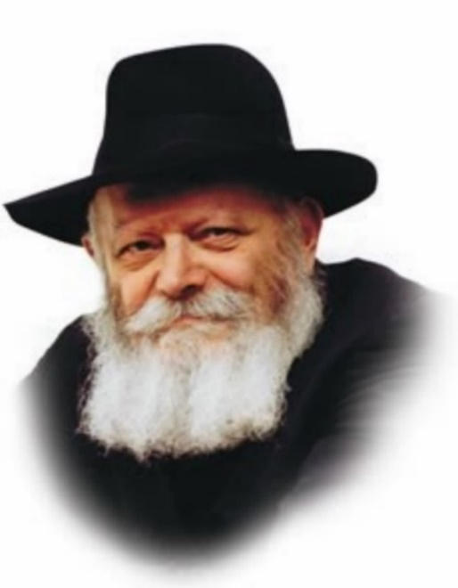

In this week’s Torah portion, Ki Tisa, we read about the Kiyor, the Laver, which was a large copper receptacle that held water. It had a stand, also made of copper. It had several spigots, from which the Kohanim, the priests, would wash their hands and feet, before doing the Temple service.

What was unique about the Kiyor was not so much what it was, or how it was used, but rather where the copper, of which it was made, came from.

In next week’s portion, the commentator Rashi explains the above question. The women gathered at Moses’s tent with the copper mirrors they used to beautify themselves, intending to donate them. Moses was uncomfortable accepting these mirrors, because, seemingly, they were used for the evil inclination’s bidding.

**They (the Kiyor) Are Most Precious to Me of All**

G-d told Moses to accept them, “for they are most precious to me of all.”

Because of these mirrors, the women established great numbers in Egypt. When their husbands would be exhausted, laboring under Egyptian bondage, they would go out and greet them with food and drink. They would feed them, and entice them with words, they would hold the mirror in a way that both her and her husband could be seen together, she would say “I am prettier than you.” In this manner she would awaken his urge to be with her...

It is with these mirrors that the Kiyor was made, for the Kiyor is to bring peace between husband and wife...

How important is the relationship of a couple to G-d? How is it that an instrument of vanity is most precious to Him?

In Song of Songs, King Solomon compares our relationship with G-d, to the relationship of a husband and wife. This relationship with G-d is the foundation on which our purpose and mission as the Jewish people is established. Every mitzvah, every prayer and every part of Torah we learn, comes down to this relationship – being one with G-d.

**A Relationship that is So Central to Judaism**

The microcosm of this relationship is that of a husband and wife. This relationship is so central to Judaism, that the mirrors that brought husband and wife together as one, are not only special, but most precious of all. It is so important that no service could be done in the Temple before washing hands using water from the Kiyor, which was made from these mirrors. The Kiyor was placed between the altar and the Holies, the center of all of the action in the Temple. It was seen and served as a reminder of the importance of the husband-and-wife relationship.

The Kiyor, made of these mirrors and placed centrally in the Temple, is a reminder that marriage and marital harmony is central to Judaism, it is the foundation of Jewish life, and it is not just special, to G-d it is most precious of all.

Adapted by Rabbi Yitzi Hurwitz from the teachings of the Rebbe, yitzihurwitz.blogspot.com. Rabbi Hurwitz, who is battling ALS, and his wife Dina, are emissaries of the Rebbe in Temecula, Ca.

*Reprinted from the Parshat Ki Sisa 5782/2022 edition of L’Chaim (Issue #1711) Adapted from the teachings of the Lubavitcher Rebbe, zt”l.*

**Thoughts on the Parsha**

*When you take a census....every man shall give G-d an atonement for his soul....This they shall give....a half-shekel. (Exod. 30:12-13)*

Moses could not understand how money can accomplish forgiveness for the soul. G-d showed Moses a fiery coin which weighed a half-shekel, and He explained that a coin by itself cannot atone for a grave sin. However, if one gives with warmth and enthusiasm that comes from the fiery core of the Jewish soul, then a coin can truly become the cause of forgiveness. (Likutei Sichot)

*Reprinted from the Parshat Ki Sisa 5782 edition of L’Chaim.*

**Three Russian Defeats**

**By Rav Moshe Taub,**

**The Kaliver Rebbe of Williamsburg**

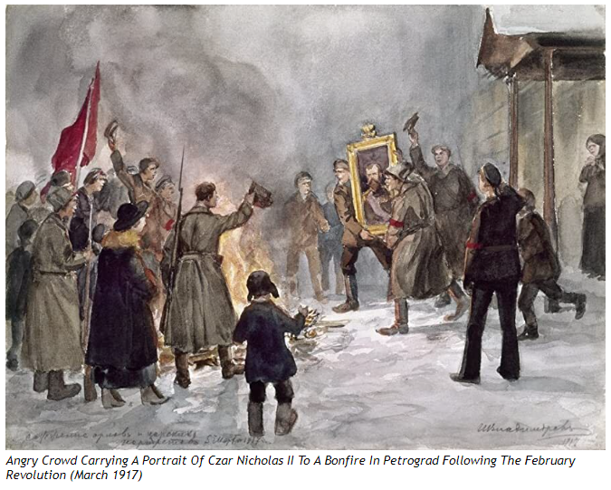

**Faith Fuels Happiness**

**Tragedies and horrible stories** can impact a person's happiness. People hear about acts of violence, homicides and terrorism taking place throughout the world. They are worried, anxious, and concerned about the speculation that nations are on the verge of war with designs to destroy and annihilate one another.

These worries foster a sense of unease and unsettledness. Their potential happiness is overshadowed by all of their angst.

*Emunah* alleviates all of these worries and concerns and allows a Jew to find happiness in the security of his faith. Jews need to strengthen their *emunah*, faith, during times of uncertainty and anxiety. They need to believe that everything that occurs in this world is an expression of a Divine Design, a providence, *Hashgacha pratis*, even a heinous crime like murder.

A Jew must have the faith that a person can only be taken from this world by Heavenly decree. Nothing in this world that can happen of its own volition. A murder can only happen if the spiritual forces of impurity have been given permission from the Heavens to corrupt a specific place and time.

**Purim's Power**

There are many stories of *tzaddikim* throughout the generations, who used their power of *kedusha* and holiness to nullify and abolish the forces of impurity that corrupt the enemies of the Jewish people, and it was seen clearly that the enemies are controlled by spiritual forces.

This was especially evident during the miracle of Purim, when Mordechai successfully utilized his power of *kedusha*, holiness, to destroy Haman and his impurities. Through that effort and the subsequent miraculous salvation, the month of Adar became an auspicious time to overcome the forces of evil, in particular the wicked nations who persecute the Jewish people. As *Chazal* taught us (*Ta'anis* 29a) that if a Jew has a court case with a non-Jew, he should do everything in his power to have the case heard in the month of Adar when the Jews have a good mazal.

The *Meor Einayim* (*Parshas Mikeitz*) explains that when a Jew performs a *mitzvah* that celebrates a specific moment in time, the same spiritual dynamics are awakened as when those events originally happened, and the *mitzvah* was first given. Purim was a time when the *Amalek* fell. Therefore, in every generation, the day of Purim and its *mitzvos* are embedded with those same potent spiritual capabilities. Every year, through the holiday of Purim, the Jews can harness the strength and ability to cause the downfall of wicked nations.

**Modern Day Mordechai**

It is worth mentioning as a sample, that this was seen in Russia's history.

In the record of Russian history, there were three times when the heads of state, who have been true enemies of *Yidden* and *Yiddishkeit*, were abruptly overthrown. Each of these incidents occurred on Purim, the day when the righteous succeeded in overthrowing and nullifying the forces of impurity.

The first time was on Purim in 1855. Nicholas I was ruling over Russia and he instituted brutal decrees on the Jewish people.

That year the *Sar Shalom of Belz,*zt"l, spoke at his Purim *tish* focusing on the topic of the enemies of the Jewish people, the tyrants who intend to do them harm. The Rebbe explained that the Heavens give permission to the wicked to inflict their evil on the world, but there is a limit, a quota. And, when that limit is met, those wicked individuals must be removed from the world. Then the Rebbe rose to his feet and said: "The wicked Nicholas has already filled his quota, and the time has arrived for his downfall."

Afterwards, the world had learned that Nicholas I died that very day.

The second time was on Purim in 1907, the year when Nicholas II signed into law harsh decrees on the Jewish citizens.

In that year, *R' Shalom Ber of Lubavitch,*zt"l, delivered a Chassidic discourse discussing the power of the righteous to overthrow the wicked. Then, he travelled to the capital city of Petersburg to read the *Megilah*. On that same day, on Purim, the revolutionists began rioting in the capital, resulting in the eventual dissolution of the Russian government. They killed Nicholas II in the end.

In 1953, Stalin, may his name be erased, decided to deport all of the Jewish citizens to Siberia. This would be the third time the wicked rulers of Russia would be destroyed on Purim.

R' Shalom Schnitzler, the late head of the *beis din*, told me that at that time he was living in the Russian town of Hungary. A group of Jews from his town decided to travel to the city of Kalov, in order to pray at the gravesite of my holy ancestor, *R' Yitzhak Isaac of Kalov,*zt"l. This holy site is famous for being a place where one could manifest the power of salvation in the merit and strength of the tremendous *tzadik*. They arrived before Purim. They prayed for an end to their suffering and their cries pierced Heaven's heart and the heavens opened. A short time later, they received the good news that Stalin had died suddenly that Purim day.

**Rooted in Faith**

The power to abolish these impure forces and to destroy Israel's enemies, is dependent on holy Jews strengthening their *emunah* and faith, to the point that they believe fully and completely in *Hashem*, they trust that everything in this world is from His Divine Intervention and, subsequently, they do not to fear their enemies at all.

*R' Yosef Yitzchak* of Lubavitch zt"l was engaged in spreading the Yiddishkeit throughout Russia, even though it was in direct violation of the laws imposed by the Communist Party who outlawed any public display of religion. Eventually, he was arrested and held in a prison that was known for its inhumane and nightmarish conditions. The Rebbe decided that since he was imprisoned for spreading Torah and Yiddishkeit, then the Communists Party and its enforcers were clearly fueled by the forces of impurity. But their power was only superficial and temporary. Eventually, they would be vanquished. Therefore, he did not bend to their will in the slightest.

He remained steadfast in his ambivalence towards the guards and interrogators. When they ordered him to remove his *tzitzit*, he did not listen. And even when the miracle happened and they came to inform the Rebbe of his surprising release, the Rebbe would not stand for the warden as was required by the prison rules. He viewed that even that small gesture would be perceived as an acceptance of their authority over him. He would not allow that. Miraculously, they subjugated themselves to him!

**Mordechai's Insolence**

This can justify Mordechai not moving at all when Haman passed, as it says (Esther 5:9) *"he neither rose nor stirred because of him*..." He did not want his movements to be misconstrued and perceived as a sign of submission or recognition of the power of impurity and evil embodied by Haman.

Instead, he gathered the school children to pray to *Hashem*, demonstrating that a Jew only needs to depend on *Hashem*, that everything is in His control and, therefore, there is nothing to fear. He strengthened the Jews' *emunah,*reminding them that everything in the world is *Hashgacha Pratis.*

Victory during the war with the *Amalek* also depended on this level of *emunah. Chazal* taught (*Rosh Hashanah* 29a), that the Jews overcame the power of *Amalek* when *Moshe* raised his hands upward causing them to look towards the Heavens. It was a reminder to have *emunah* that everything is the result of a Heavenly Decree. When the Jews held to that *emunah*, the *Amlaek* was weakened and defeated.

Therefore, we can suggest that this is the reason we read *Parshas Zachor* about the war with the *Amalek* on the *Shabbos* before Purim. Both these events express the same theme. The purpose of Purim is also to remember to annihilate the *Amalek* and its impure forces in each generation by strengthening our *emunah* and prayer.

*Reprinted from the Parshas Zachor and Purim 5783 email of the Weekly Message of the Kalever Rebbe.*

*And the Children of Israel shall keep the Sabbath, to observe the Sabbath (Ex. 31:16)*

The holiness of Shabbat exists independently of the Jew; all he is enjoined to do is guard it. Yet at the same time, the Jew is commanded to observe Shabbat by his own actions, adding to its inherent holiness with his preparation and service. (Sefer Hamaamarim Tav Shin)

*Reprinted from the Parshat Ki Sisa 5782 edition of L’Chaim.*

**Why Are the Ultra-Orthodox the Happiest Group in Israel?**

***A strong sense of community and a different***

***set of aspirations have a lot to do with it.***

**By Liora Rosenblatt**

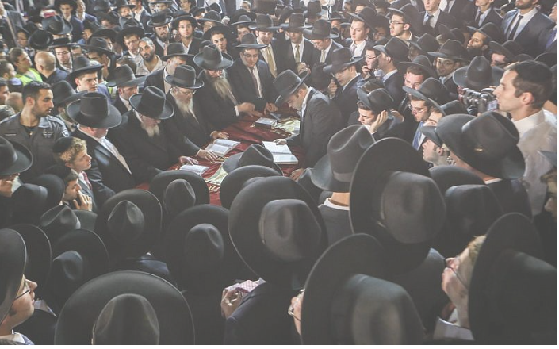

**Ultra-Orthodox Jews celebrate the end of the Shavuot holiday in Jerusalem’s Old City, June 12, 2016.**

**Haredi Jews** are the [happiest group](https://www.maariv.co.il/news/israel/Article-948145) in Israel, according to a 2022 life satisfaction and happiness survey conducted by Panels Politics. However, a report prepared by the Israel Democracy Institute noted that more than 44% of them live below the [poverty line](https://en.idi.org.il/articles/47009).

But only a very small percentage of the respondents felt poor. In a world where happiness is often associated with wealth, how are we to understand this apparent contradiction?

The Jewish tradition contains a vast amount of teachings that instruct its adapts on how to live and conceptualize life. Pirkei Avot, or the Ethics of our Fathers, a famous character development book, teaches: “Who is rich? He who is happy in his lot” (Mishna, Pirkei Avot 4). Perhaps this is the first way to explain the situation. Judaism teaches that you will receive whatever is meant for you, and if you don’t have it, then it is not supposed to be yours.

**Typically Very Spiritual and Non-Materialistic**

Benjamin Porat, director of the Institute for Research in Jewish Law at the Hebrew University of Jerusalem, says that “haredim are typically very spiritual and non-materialistic; they measure happiness according to a successful spiritual life, not by the cars one drives or the clothes one wears. There is no correlation between their level of poverty and their spiritual goals. It’s not that they don’t have desires or wishes, but those are more geared towards spiritual goals than material ones.”

This life perspective of being content with one’s situation and striving for spiritual rather than material goals certainly helps to explain why haredim are happy despite their generally precarious economic situation.

Bottom of Form

Moreover, a 2019 research article focusing on life satisfaction in the haredi sector reported that a “positive connection was found between prioritizing positivity and life satisfaction for individuals with a high [sense of community](https://www.tandfonline.com/doi/abs/10.1080/00223980.2019.1704392?journalCode=vjrl20), but a negative connection for those with a low sense of community.” This signifies that being happy with one’s lot also means exhibiting a positive attitude towards life, and that a sense of community plays an important role in feelings of happiness. This leads us to our third point.

Haredim’s extensive community support can also explain their happiness level. Most haredim choose to live in exclusively Orthodox areas where they feel surrounded and connected to people who share similar beliefs.

**The Eyes of their Community**

Nitsa (Kaliner) Kasir, a senior researcher on haredi-related issues, states: “They live in a closed community, and they therefore perceive the world according to the eyes of their community. If a certain community lives within another one whose conditions are better, they will compare themselves to it. But because the haredi community is closed, it therefore only has to compare itself to the haredi community at large. This greatly impacts their life perception, and consequently, their level of happiness.”

Additionally, community support can be expressed through deeds of chesed (loving-kindness), high levels of volunteerism, donations, mutual aid and care for the needy and elderly, as well as several frameworks of economic support. The community is a central pillar of the haredi lifestyle, and it results in its members feeling cared for, surrounded and content.

Orthodox Jews’ economic lifestyle and consumer behavior further explain their happiness level. The character of the haredi community, which differs significantly from that of Western society, forms an almost entirely closed economic market and enables its members to provide for their needs despite their lower incomes.

For instance, according to Kasir, “the Orthodox community often reuses non-perishable products, such as clothes, by passing them down among children in the family. They make purchases according to actual needs, and their spending on luxuries is very low.”

**Seeking to Safeguard Observance of Religious Laws**

The haredim’s donation and loan mechanisms include different sorts of gma’him, which are types of community banks that do not charge interest or fees.

Expenses for electronic devices, such as cell phones and computers, are much lower among haredim compared to the rest of the Israeli population. Only one-third of adult members own a cellphone, of which only a small amount are smartphones, mostly due to restrictions on internet use. Television is rare in the haredi sector, as its members seek to safeguard observance of the laws of preserving one’s eyes from immodest behavior.

Moreover, there are certain products, services and activities that Haredim do not use: cinemas and mixed concerts, for example. There are other products and services, including transportation and communications, that the Orthodox community uses differently than other Israelis.

These phenomena invite us to revisit the meaning and feeling of happiness. Society at large places great emphasis on wealth and social status but Orthodox people may have one or two things to teach the Western mind about happiness.

*Reprinted from the February 23, 2023 dispatch of the JNS*

**The Chida**

R’ Chaim Yosef Dovid Azulay, known as the Chida, was one of the greatest Sephardic Gedolim. It is truly wondrous how the Chida wrote more than 50 seforim in his lifetime, especially when most were written during his travels from land to land. The Chida’s seforim encompassed many different areas of Torah including commentaries, midrash, halacha, kabbalah, mussar, history and bibliographies.

*Reprinted from the Parshas Ki Sisa 5783 email of The Weekly Vort.*